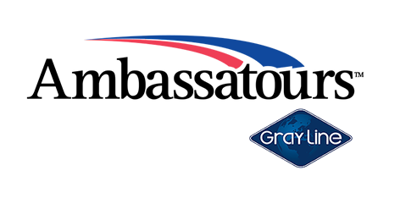 | 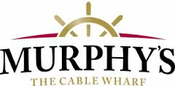

Farwell Leaves Ambassatours To Focus on Amphibious Vehicle Manufacturing

Halifax, Nova Scotia (January 20, 2017) —

Atlantic Canada’s premiere tour company, Ambassatours Gray Line’s CEO Dennis Campbell, has announced that its President, Jeff Farwell, is leaving the company to return to his entrepreneurial roots: manufacturing new amphibious vehicles.

“We have been proud to grow Murphy’s within the Ambassatours family over the last couple of years since our merger,” said Dennis Campbell, CEO Ambassatours Gray Line. “We wish Jeff all the best with his new endeavors and we look forward to continuing to enhance Murphy’s as a key segment of our tour company.”

Ambassatours and Murphy’s the Cable Wharf joined forces in 2014. Since then, they have been implementing new innovations to their amphibious vehicles, the Harbour Hoppers, to stay at the cutting edge of the water touring business. The Ambassatours marine team, lead by Farwell, worked with the Nova Scotia Community College to completely redesign and refurbish two Harbour Hoppers in time for a summer 2017 launch. Improvements include: bigger overall size, more stability, new engines, new drive trains, new operating systems, better passenger comforts, and wheelchair access

In his new venture, Farwell intends to manufacture amphibious vehicles, based on a prototype developed during the refurbishment of the Ambassatours’ Harbour Hoppers.

“The merger with Ambassatours has been a great thing for Murphy’s,” noted Jeff Farwell, “Personally, now, I’m excited to pursue the unique opportunity to manufacture these units for eager worldwide markets.”

Following this partner buyout on January 20th, Ambassatours Gray Line and Murphy’s the Cable Wharf will continue business as usual with Dennis Campbell remaining CEO and majority shareholder, and Mary Dempster, COO, and Sean Buckland, Director of Sales as minority shareholders. Sarah Godin continues as Murphy’s Operations Manager, a position she has held since the merger in August 2014.

For more information about Ambassatours Gray Line or Murphy’s The Cable Wharf, please visit the websites at www.ambasstours.com and www.mtcw.ca.

- 30 -

About Ambassatours Gray Line
Ambassatours Gray Line is Atlantic Canada’s premier tour company operating land and water sightseeing tours throughout Nova Scotia, New Brunswick and Prince Edward Island. Ambassatours also services the charter market throughout Atlantic Canada and enjoys first billing as the top service provider of shore excursions to all major cruise lines entering Halifax, Sydney, Charlottetown and Saint John. The company provides charter bus services across Canada and throughout the United States, operating a fleet of over 70 highway coaches, mini-buses, and vintage British double decker buses. Under the Murphy’s brands, the company operates Halifax’s most popular water-based tours aboard the the Harbour Hoppers as well as Theodore Tugboat, the Tall Ship Silva and four other popular tour boats on the Halifax waterfront. Ambassatours Gray Line, and its Murphy’s brands, have been offering tours and sightseeing in Atlantic Canada since the mid-80s. In peak season the company employs over 400 staff from its four operating locations, making it the largest combined land and water tour company in Canada.

For additional press photos or to arrange an interview, contact:
Terri McCulloch
Communications Manager
Ambassatours Gray Line Limited
cell 902-499-6725
tmcculloch@ambassatours.com

